

***School of Mechanical & Manufacturing Engineering (SMME),***

***National University of Science and Technology (NUST),***

***Sector H-12, Islamabad***

Program: BE-Aerospace Section: AE-01

Session: Spring 2024 Semester: 2nd

Course Title: Engineering Drawing AE-103

***Assignment # 1***

***“Orthographic Projection”***

***Name:* Muhammad Areeb Arshad**

***CMS:*** **461157**

**OBJECTIVE:**Top of Form

The main goal of this engineering drawing task was to grasp the fundamentals and techniques of orthographic projection, with a specific emphasis on utilizing the first angle view approach within the AutoCAD software. Through this assignment, I aimed to develop proficiency in accurately translating three-dimensional objects into two-dimensional representations, enhancing my comprehension of projection systems and the standards of technical drawing.

**DEFINITIONS:**

**Orthographic Projection**

A fundamental technique used in technical drawing to represent the three-dimensional form of an object in two dimensions by projecting its views onto perpendicular planes.

**First Angle Projection**

In this method of orthographic projection, the object is positioned in the first quadrant of 3D space, and its views are projected onto planes situated between the object and the observer.

**Third Angle Projection**

In this method of orthographic projection, the object is positioned in the third quadrant of 3D space, and its views are projected onto planes situated beyond the object and the observer.

**Visible Edges**

These lines represent the outlines and features of the object that are directly visible in the orthographic projections.

**Hidden Edges**

Lines representing features of the object that are obscured from direct view in the given projections but are essential for conveying complete information about the object's geometry.

**Centre Lines**

These lines indicate the center of symmetry, rotation, or other significant features of cylindrical or symmetrical parts.

**KEY CONCEPTS:**

**Projection Systems:**

There are two types of projection systems:

1. 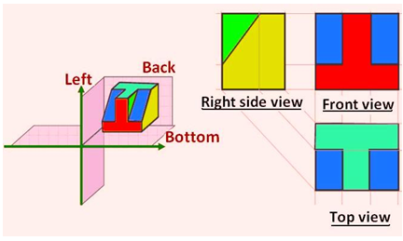**First Angle Projection**: This method of orthographic projection places the object in the first quadrant of 3D space, with its views projected onto planes positioned between the object and the observer.

*Fig 1.1 – Object in 1st Angle Projection & Orthographic View****.***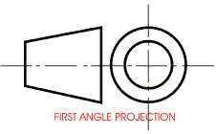*Fig 1.2 –Drafting Standard for 1st Angle Projection****.***

1. **Third Angle Projection**: In contrast, the third angle projection system positions the object in the third quadrant of 3D space, with its views projected onto planes situated beyond the object and the observer.  
   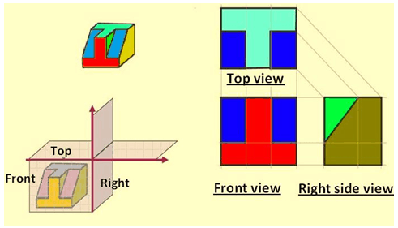

*Fig 1.3 – Object in 3rd Angle Projection & Orthographic View****.***

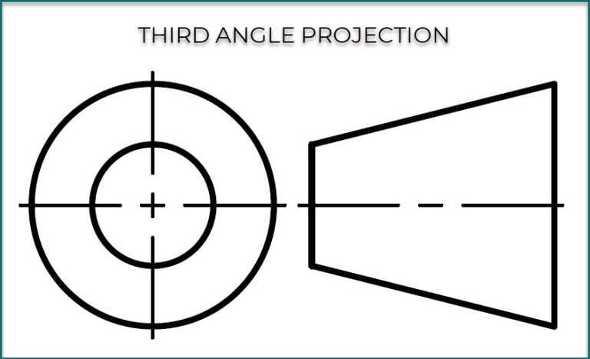*Fig 1.4 –Drafting Standard for 3rd Angle Projection****.***  
  
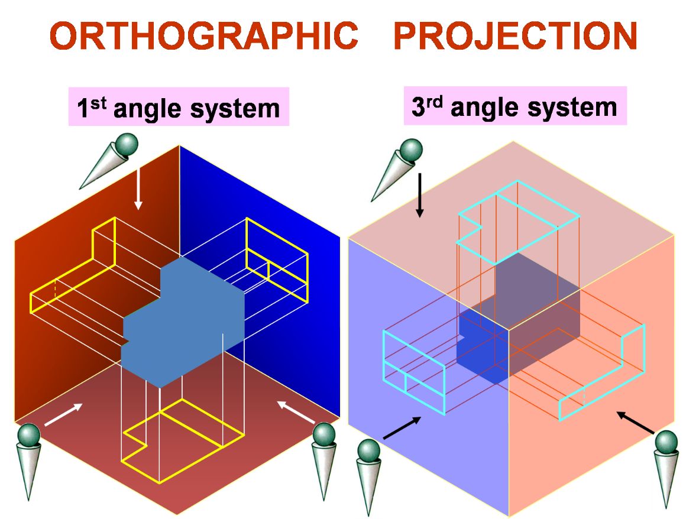

*Fig 1.5 – Difference between 1st and 3rd Angle Projection.*

**PROCEDURE:**

Following steps were followed in each drawing:

1. **Creating Layout Page:** I created a Layout Page for my drawing on an **A2** Equivalent sheet with a distance of 20mm from the left and 10mm from the rest of the sides.
2. **Creating the Title Box:** I then made the Title box of the following dimensions:

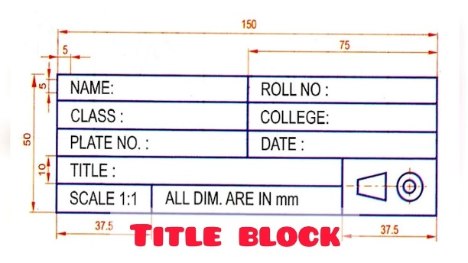*Fig 1.6 – Standard Title box.*

1. **Dividing the page**: I then divided the page into half both vertically and horizontally by creating a line extending from the midpoint till the other side of the page.
2. **Starting with the Front View**: I started all my drawings with the front view.
3. **Making the side view**s: Then I made the side view by extending lines from the corner of the front view accordingly.
4. **Making the Top or Bottom view**: The Top and Bottom Vies were also created by extending lines from the corners of the Front View.
5. **Trimming**: I then trimmed off extra edges and division lines of the page.
6. Adding different lines: I coloured and added the required lines like the **Centre Line & Hidden Lines**.
7. **Dimensioning**: I then added appropreate dimensions to the drawing ensuring that unnecessary dimensions are not added and all the necessary one are shown.
8. **Review**: I reviewed my drawing to ensure that there are no mistakes in the drawing.

**Drawing No. 1**

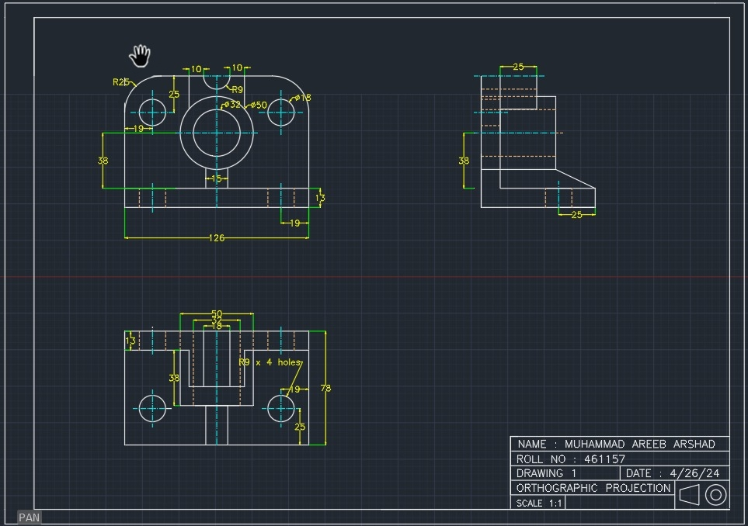

* This drawing was made with the **Left Side View.**

**Drawing No. 2**

* This drawing was made with the **Right Side View**.

**Drawing No. 3**

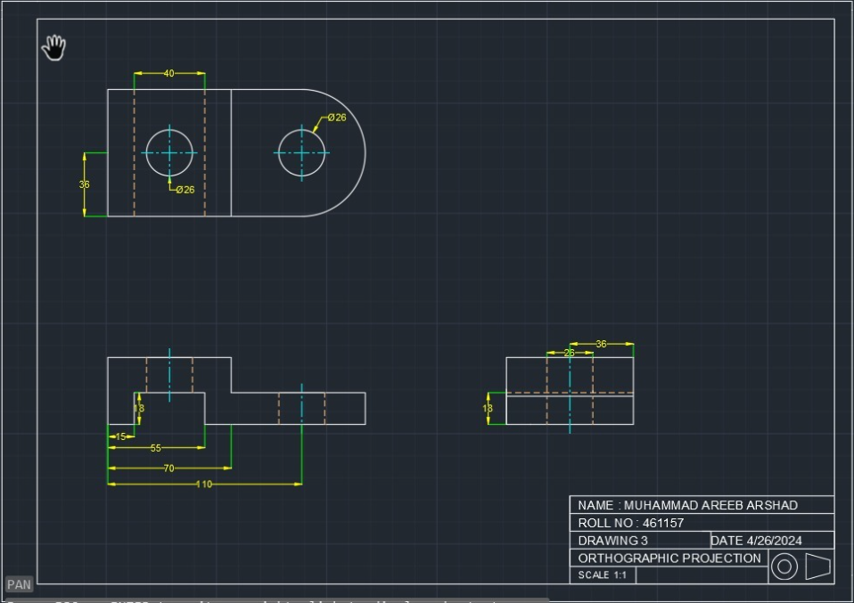

* This drawing was made in the **3rd Angle Projection** with **Right Side View**.

**CONCLUSION:**

In conclusion, this assignment provided a thorough investigation into orthographic projection techniques with AutoCAD.

Through the application of 1st Angle Projection principles, students acquired valuable insights into the detailed process of representing three-dimensional objects in two dimensions.

This exercise not only improved proficiency in AutoCAD but also deepened understanding of projection systems, line conventions, and layout organization, speed and accuracy and allowed me to learn the use of this software much better.

